SCHOOL OF COMPUTER SCIENCE AND ARTIFICIAL INTELLIGENCE |  |  |  |  | DEPARTMENT OF COMPUTER SCIENCE ENGINEERING
Program Name: B. Tech |  |  |  | Assignment Type: Lab |  |  | Academic Year:2025-2026
Course Coordinator Name |  |  |  | Venkataramana Veeramsetty
Instructor(s) Name
  Dr. V. Venkataramana (Co-ordinator)
  Dr. T. Sampath Kumar
  Dr. Pramoda Patro
  Dr. Brij Kishor Tiwari
  Dr.J.Ravichander
  Dr. Mohammand Ali Shaik
  Dr. Anirodh Kumar
  Mr. S.Naresh Kumar
  Dr. RAJESH VELPULA
  Mr. Kundhan Kumar
  Ms. Ch.Rajitha
  Mr. M Prakash
  Mr. B.Raju
  Intern 1 (Dharma teja)
  Intern 2 (Sai Prasad)
  Intern 3 (Sowmya)
  NS_2 ( Mounika)
Course Code |  |  | 24CS002PC215 | Course Title |  | AI Assisted Coding
Year/Sem |  |  | II/I | Regulation |  | R24
Date and Day  of Assignment |  |  | Week10 - Monday | Time(s)
Duration |  |  | 2 Hours | Applicable to  Batches
AssignmentNumber:20.1(Present assignment number)/24(Total number of assignments)
 | Q.No. | Question |  |  |  |  |  | Expected Time  to complete
 | 1 | Lab 20 – Security Testing: Identifying Vulnerabilities in AI-Generated Code  Lab Objectives:  - Understand how to test AI-generated code for common security vulnerabilities.  - Learn to apply secure coding principles while analyzing AI outputs.  - Practice detecting risks such as SQL injection, XSS, hardcoded credentials, and weak encryption.  - Enhance code reliability and safety by using AI for secure refactoring.  Task 1 – Input Validation Check  Task:  Analyze an AI-generated Python login script for input validation vulnerabilities.  Instructions:  - Prompt AI to generate a simple username-password login program.  - Review whether input sanitization and validation are implemented.  - Suggest secure improvements (e.g., using re for input validation).  Expected Output:  - A secure version of the login script with proper input validation.  Prompt:  Write a single Python script that implements a secure login demo: create demo users with bcrypt-hashed passwords, validate username (3–15 letters/numbers/_) and password format (8–32 allowed chars), hide password input with getpass, allow 3 attempts with a short lockout on failure, and print clear success/failure messages.  Code:  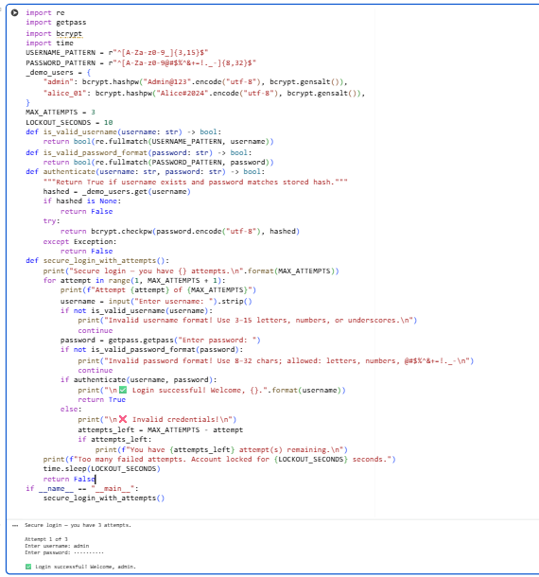  Task 2 – SQL Injection Prevention  Task:  Test an AI-generated script that performs SQL queries on a database.  Instructions:  - Ask AI to generate a Python script using SQLite/MySQL to fetch user details.  - Identify if the code is vulnerable to SQL injection (e.g., using string concatenation in queries).  - Refactor using parameterized queries (prepared statements).  Expected Output:  - A secure database query script resistant to SQL injection.  Prompt:  Create an in-memory SQLite Python demo that:  - creates a users table and inserts sample users  - shows a vulnerable function that looks up a user by concatenating input into SQL and runs it with input "admin" and "admin' OR '1'='1"  - shows a secure version using parameterized queries and runs the same inputs to demonstrate the attack fails  - print clear console output for each step.  Code:  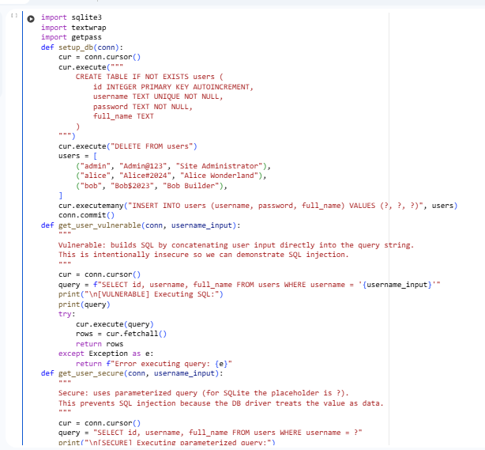  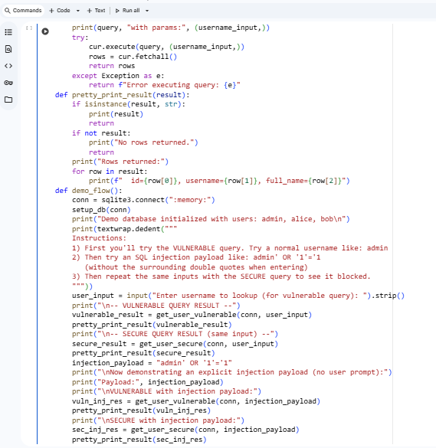  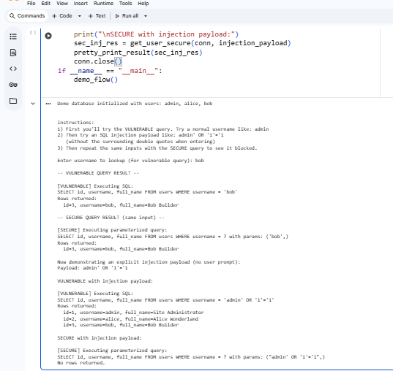  Task 3 – Cross-Site Scripting (XSS) Check  Task:  Evaluate an AI-generated HTML form with JavaScript for XSS vulnerabilities.  Instructions:  - Ask AI to generate a feedback form with JavaScript-based output.  - Test whether untrusted inputs are directly rendered without escaping.  - Implement secure measures (e.g., escaping HTML entities, using CSP).  Expected Output:  - A secure form that prevents XSS attacks.  Prompt:  Write an HTML feedback form with name and feedback input. Then check for security issues and fix them using secure coding practices. Compare before and after versions.  Code:  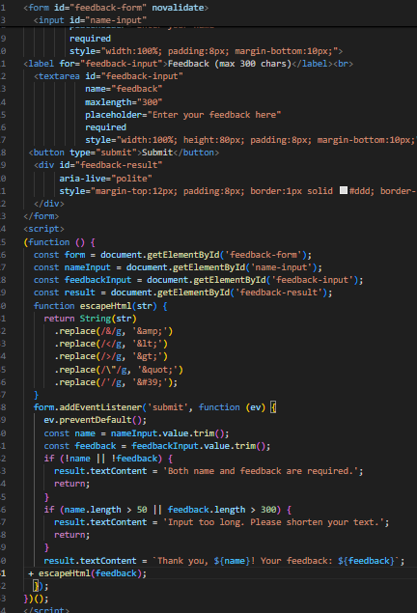  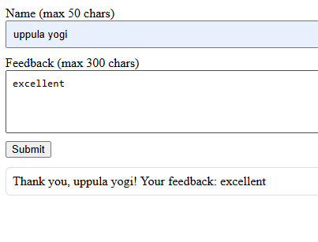  Comparison:  Insecure:  Takes user input directly and displays it without validation, allowing XSS attacks.  Secure:  Validates and sanitizes input before displaying, preventing XSS and ensuring safe feedback handling.  Task 4 – Real-Time Application: Security Audit of AI-Generated Code  Scenario:  Students pick an AI-generated project snippet (e.g., login form, API integration, or file upload).  Instructions:  - Perform a security audit to detect possible vulnerabilities.  - Prompt AI to suggest secure coding practices to fix issues.  - Compare insecure vs secure versions side by side.  Expected Output:  - A security-audited code snippet with documented vulnerabilities and fixes.  Prompt:  Generate an insecure AI-generated HTML and JavaScript login form. Then perform a security audit to find vulnerabilities like XSS or insecure data handling. Suggest secure coding practices to fix them and show the secure version with a short comparison.  Secure version code:  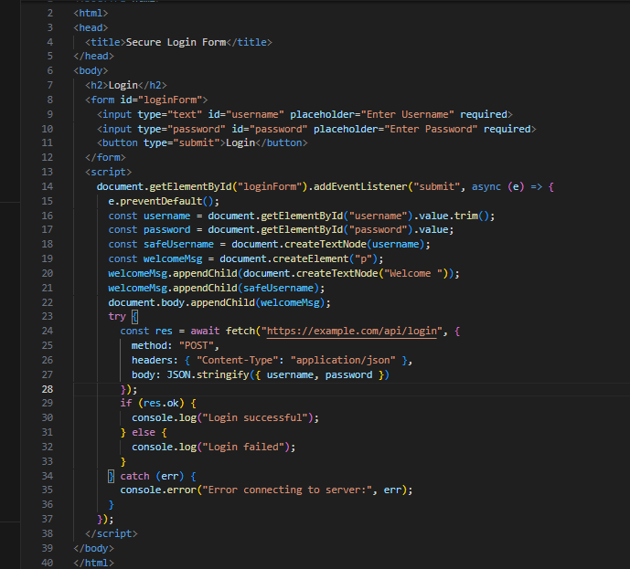  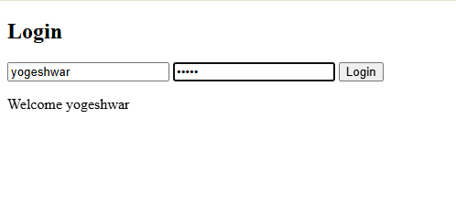  Comparison:  • Insecure Version: Directly injects user input into the DOM, exposing to XSS attacks and sends passwords in plain text via URL.  • Secure Version: Sanitizes input, uses POST with JSON payload, requires HTTPS, and avoids unsafe DOM manipulation.  ✅ Deliverables (For All Tasks)  - AI-generated prompts for code and test case generation.  - At least 3 assert test cases for each task.  - AI-generated initial code and execution screenshots.  - Analysis of whether code passes all tests.  - Improved final version with inline comments and explanation.  - Compiled report (Word/PDF) with prompts, test cases, assertions, code, and output. |  |  |  |  |  | Week10 - Monday

